# ADVENTURE OPTIONAL SILVER ROSE QUESTS

## Mary Margaret at the Silver Vine Inn

She has a wooden necklace that belonged to a wood elf that had stayed there. The Elf’s fallen lover had carved it for her before he perished in battle. The wood elf had lost it and was heartbroken but had to return to the temporal forest.

Mary Margaret needs someone to take it to her.

## Talos Temple

Taoba has a mini quest for you. Someone has stolen a relic from the temple. Get it back to gain +2 favor with Talos (must have +5 favor to cross mountain)

### **Riffraff**

The blacksmith tells you about the large amount of orphaned kids coming in from all over talking non-sense about their villages being attacked by corpses. They’ve been mucking up the town and causing issues everywhere. Murmurs something about a reward if the children are dealt with, and he doesn’t care how.

He hears the children have holed up in the sewers, which is why the city stinks.

### **The Sewers**

The sewers are riddled with rats. Although easy enough to take out, the rats seem aggressive and may attack.

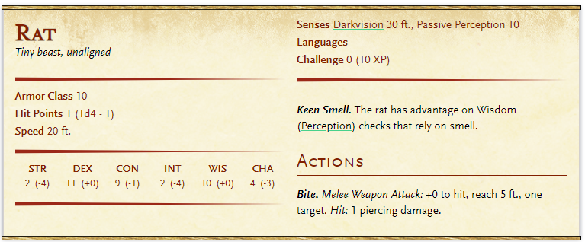

2 Giant Rat attacks at random points.

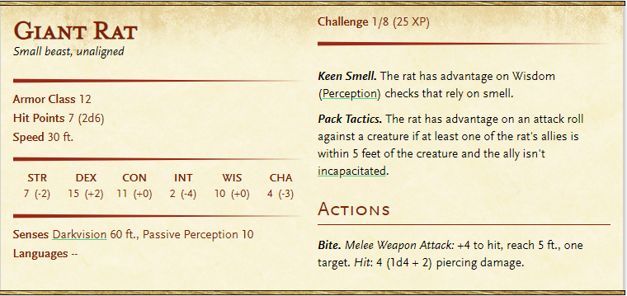

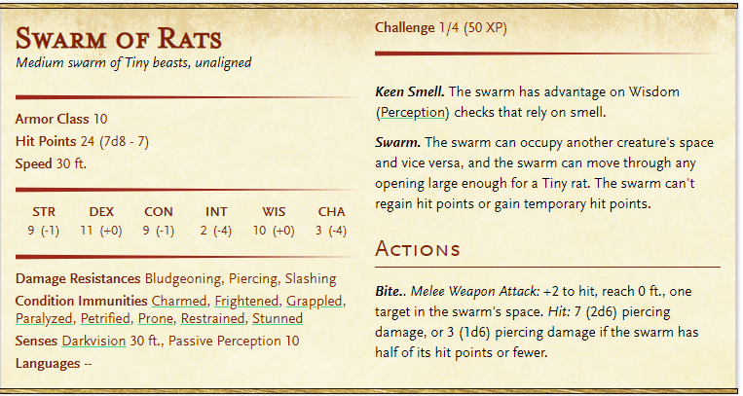

You hear a child shriek at the end of the tunnel. As you approach, you see a giant rat with what looks like the body of a very hairy man: It is a wererat! You can see blood pooling in the wererats fur on the side of its body.

Wisdom (arcana) +10 check to see if they know if a wererat bite can cause wererat lycanthropy.

WereRat HP = 25 (because it’s injured already)

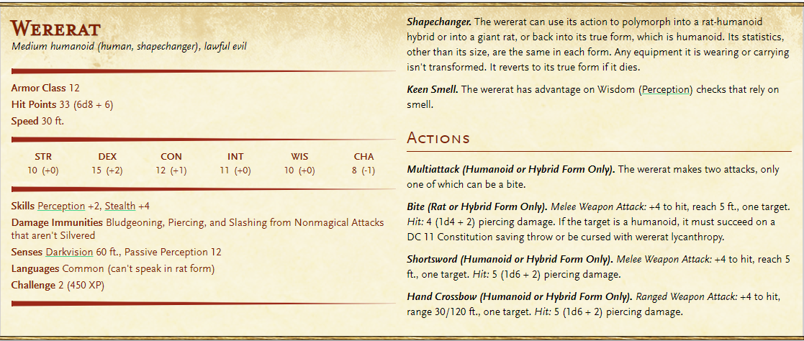

If you kill it, the boy, Elis is super happy. He tells you that the wererat was forcing the children to do bad things up top and that if you disobeyed him, he would kill your friends. But now that he’s gone, the kids will stop causing issues up top.

Additionally, the boy tells you he stole the relic from the temple because his sister is sick and he needs 20 gp to save her. Fortunately, someone is interested in buying it. You can either

1. Let the boy sell it and be done with the mission
2. Buy the relic from the boy for 20gp
3. Give the girl the health elixir from Mary Margaret if you got it/still have it

### Riffraff Return

A stinky small satchel full of blinding powder (3 uses), a Philter of Love potion (once consumed, the consumer becomes charmed by first creature it sees. If target is a creature and gender that it is normally attacked to, they believe this is their true love. Lasts 1 hour), and half used bottle of Potion of Hill Giant Strength (+ 21 strength for 1 hour, but since half drank, 30 min).

### Temple Return

When you go back to the temple if you have the relic, Taoba is ecstatic. He says he will pray to Talos about you!

He tells you to return to the temple later for more tasks.